Lindenwood University
College of Arts and Humanities

COLOR SHIFT: A GRAPHIC DESIGN PROCESS BOOK EXPLORING HOW COLOR AND MOTION INFLUENCE EMOTIONAL PERCEPTION AND BRAND CONNECTION IN AFFORDABLE WOMEN’S FASHION JEWELRY
by

Elizabeth Voight

A Prospectus of a Thesis Submitted in Partial Fulfillment of the Requirements
for the Degree of Master of Arts in Graphic Design

July 2026

Background
My primary area of interest is graphic design, a field in which I have developed over 15 years of professional experience, primarily within corporate environments spanning both the retail and medical industries. I earned my Bachelor of Fine Arts in Graphic Design from the University of Wisconsin–Stevens Point in 2011, which provided the foundation for my career in visual communication. Following graduation, I worked for over a decade as a graphic designer at Ashley Furniture Industries' corporate headquarters in Arcadia, Wisconsin. In this role, I contributed to a wide range of design projects within an established brand system. I later transitioned to my current remote position as a graphic designer with a venous health care company called Center for Vein Restoration, based in the Washington, D.C. area, where I have been the primary graphic designer since 2021.
Throughout my career, I have specialized in in-house design, producing print and digital materials, including marketing collateral, event assets, presentations, and logos. My experience spans working within well-established brand standards and contributing to a brand's evolution from its early stages. This dual perspective has strengthened my ability to maintain visual consistency while also adapting to new branding opportunities. I have consistently been drawn to the process of building cohesive visual systems and applying them across multiple platforms, ensuring that a brand’s identity remains clear and recognizable.
My interest in graphic design stems from its unique combination of artistic creativity and technological application. As a lifelong visual learner, passionate about art, typography, and branding, I have consistently been fascinated by how design can communicate complex ideas in a clear and engaging way. In my professional work, I especially enjoy transforming challenging ideas into visual representations that boost understanding and user engagement. I view graphic design not only as an art form, but as a purposeful method of communication that bridges aesthetics and functionality.
My proposed thesis project builds upon my professional background and focuses on further developing my expertise in branding and color theory. Through this work, I aim to refine my design process, strengthen my strategic thinking, and advance my technical and conceptual skills. Ultimately, this project will support my goal of advancing to a senior-level design role by enhancing both my creative capabilities and my ability to develop and lead cohesive, effective brand systems.
Project Overview
The title of this project is Color Shift: A Graphic Design Process Book Exploring How Color and Motion Influence Emotional Perception and Brand Connection in Affordable Women’s Fashion Jewelry, which examines how manipulating color and motion within a women’s fashion jewelry brand identity system influences emotional response and brand consistency. The project uses a fictional modern jewelry brand, Quanta & Co., as the foundation of the study. While the logo, typography, and structure remain consistent, nine distinct color palettes—red, orange, yellow, green, blue, purple, pink, brown, and black—are applied individually to isolate color as the primary variable and evaluate how perception changes. I intentionally chose initial hues that stayed close to the middle range of each color, avoiding pastel tones and overly dark shades. I wanted to prevent immediate assumptions about the brand, such as lighter tones feeling too playful or darker tones feeling automatically more modern or luxurious. Using balanced mid-range hues allowed participants to focus more on the color itself and how it influenced their perception of the brand.
This approach also aligned with Quanta & Co.’s intended market position as an approachable mid-range fashion jewelry brand. For this project, mid-range refers to jewelry priced between approximately $25 and $75, utilizing affordable fashion-jewelry materials such as plated metals and synthetic stones while still offering a polished and cohesive brand experience. Quanta & Co. was conceptually developed similarly to brands such as Kendra Scott, offering fashion jewelry that can be worn casually for everyday use or styled for more elevated occasions. While the jewelry remains attainable in price, the overall customer experience was intended to feel thoughtful and branded through elements such as jewelry boxes, shopping bags, and coordinated branded assets.
Quanta & Co. was designed to feel welcoming and approachable to consumers. Unlike luxury jewelry retailers, which typically have significantly higher price points and may require appointments or controlled access to shop in-store, the brand was envisioned as an open retail environment where customers can comfortably browse and shop in person. The jewelry would also be available through accessible retail partners, such as Target, reinforcing the brand’s broad availability and consumer-friendly positioning. Rather than aiming for either a budget-focused or highly exclusive luxury aesthetic, the goal was to create a visually balanced identity that feels refined, yet relatable. This positioning also informed the survey process, as I was especially interested in gathering reactions to color palettes that may not typically be associated with jewelry brands in this category, which led to thoughtful, honest, and often engaging feedback throughout the study.
Although my professional graphic design experience has primarily been in retail and healthcare, I intentionally chose the jewelry category to explore a new industry and expand beyond the areas I have worked in previously. This project challenged me to step into an unfamiliar category, develop a brand from the ground up, and demonstrate my versatility as a designer. It also reflects my willingness to continue learning, try new creative approaches, and broaden the range of work represented in my portfolio.
Each color variation is shown across branded materials, including a vehicle wrap, shopping bag, jewelry box, stationery, digital advertisements, animated logo, and a website homepage, to test whether the brand remains cohesive and recognizable despite color changes. I selected this wide range of assets because they represent practical touchpoints within a jewelry brand’s customer experience. For example, the jewelry box and shopping bag reflect two key items a customer would receive during an in-store purchase, making them strong examples of branded packaging. The car wrap demonstrates how the brand can be extended to a larger-scale application, creating visibility beyond the store and serving as a moving advertisement that can increase awareness among potential customers. The business cards represent a classic print item that could be available in-store and included with a purchase, giving customers an easy way to stay connected with a salesperson or store manager.
The digital advertisement highlights the brand’s digital presence and reflects current marketing strategies that quickly reach both new and existing customers through online search and social media platforms. The sample website homepage and animated logo further enhance this digital experience, as many customers research products online, seek information about a company, and encounter animated logos before making a purchase. Together, this combination of print and digital assets demonstrates how a brand must function consistently across multiple environments and customer touchpoints.
From a design perspective, these assets also showcase a broad range of technical abilities while emphasizing the importance of strategic brand application. For Quanta & Co., an approachable mid-range fashion jewelry brand, the visual identity needed to remain cohesive across a variety of customer touchpoints, including packaging, print materials, digital advertising, car wrap, and digital platforms. Because the brand was conceptually developed to offer affordable jewelry that feels polished and elevated, consistency across these materials was essential in creating a recognizable and memorable customer experience. A brand isn't confined to a single item; it needs to work seamlessly across various environments while preserving a consistent visual identity. Drawing from my 15+ years of professional experience in graphic design, primarily focused on corporate branding across print and digital media, this collection reflects a realistic suite of deliverables that a designer would create for a jewelry brand in a real-world setting. Including this variety was intentional, as it demonstrates both visual execution and an understanding of how branding lives across multiple platforms and customer experiences. Animated logo designs and a coded website further expand on how motion and digital interaction can strengthen branding, increase emotional engagement, and improve memorability for consumers interacting with the brand both online and in person. A quantitative survey was created to gather audience feedback on which color variations feel more modern, playful, bold, or trustworthy, connecting audience perception to color psychology and branding theory. The final deliverable is an interactive digital process book that combines research, branding, motion graphics, and audience analysis to demonstrate how intentional color and motion choices strengthen emotional connection and brand identity.
Project Significance
This project offers a unique comparative approach to color theory by isolating color as the sole variable within a consistent brand identity system. While existing research often focuses on general color theory principles or a single-color application, this study measures how audience perception shifts without changes to layout, logo, or structure. The project is also significant in its format. Rather than a traditional written thesis, it is presented as a graphic design process book integrating visual design, written analysis, branding systems, motion graphics, survey research, and reflective commentary. This interdisciplinary approach reflects modern design practice and demonstrates how research, branding strategy, and motion design work together within a complete identity system.
Beyond its academic contribution, this project also serves as a practical resource for graphic designers across disciplines such as branding, packaging, logo design, corporate identity, print design, and digital marketing. By presenting audience feedback on how specific color palettes shape perceptions of personality, quality, and brand appeal, the project offers designers real-world insight into the impact of color selection within a brand identity system.
While traditional color theory often focuses on general psychological associations, this study applies those principles in a branding context, showing how color choices can influence consumer perceptions of a brand without altering other visual elements. The findings may help designers make more informed strategic decisions when developing visual identities, packaging systems, marketing materials, and digital experiences, ultimately strengthening brand communication and audience connection.
Project Goals
The primary goal is to deepen understanding of how color theory influences brand identity, emotional response, and brand recognition. The project also strengthens professional skills in branding, motion design, web design, research, and critical thinking.
A secondary goal is to showcase advanced, versatile design skills that support future growth in senior-level graphic design roles, particularly in branding and design strategy. By combining branding, coding, motion graphics, survey analysis, and visual storytelling, the project serves as both a professional portfolio piece and an academic contribution.
Objectives and Deliverables
The main objective is to present the research through a graphic design process book and accompanying prospectus that documents the full development of Quanta & Co., including logo sketches, brand applications for all nine color variations, animated logo designs, the coded website, and survey findings supported by data analysis. The goal is to create a project that is visually strong, academically thorough, and professionally advanced by combining theory, process documentation, audience feedback, and digital applications to demonstrate how design decisions are supported by both research and user response.
Project Originality

This project demonstrates originality in both its research focus and presentation by comparing nine color variations within the same brand identity, offering a broader analysis than studies that focus on a single color or on general branding theory. Isolating color as the sole variable provides a direct examination of how color shapes emotional response and brand interpretation. Its presentation as a visual process book, rather than a traditional text-based research paper, further strengthens its originality by integrating branding systems, motion design, website development, survey research, and reflective analysis, reflecting current industry practices and expanding beyond traditional academic formats. This thesis also builds on my professional background by deepening my expertise in branding and color theory and supporting my goal of advancing into a senior-level design role through stronger strategic thinking, technical skills, and the ability to develop cohesive, effective brand systems.

Literature Review
Color Shift: The Role of Color and Motion in Shaping Emotional Perception and Brand Identity
“Colors, like people, have distinct personalities” (Sutton, 2020, p. 30). This concept highlights the expressive and communicative role of color in graphic design and branding. Color is not merely a visual element, but a critical component of how meaning is constructed, interpreted, and experienced by audiences. In branding, color functions as both an aesthetic and strategic tool, shaping emotional responses, guiding perception, and influencing how individuals connect with a brand. As digital media environments continue to expand, the importance of color has intensified, requiring designers to consider how visual elements operate across both static and dynamic platforms. This growing complexity has led researchers to examine color from multiple perspectives, particularly focusing on its psychological associations and its application within branding contexts.
Scholarly research on color in graphic design and branding generally reflects two dominant approaches. The first examines the psychological and emotional associations of color, emphasizing relatively universal interpretations of hue and their impact on human perception. Studies within this framework suggest that colors can evoke predictable emotional responses, positioning color as a powerful tool in visual communication (Sutton, 2020; Lyu, 2023). The second approach situates color within applied branding contexts, analyzing how it influences consumer behavior, brand recognition, and market positioning across specific audiences and industries (Celhay & Luffarelli, 2024; Sun, 2023). These perspectives collectively view color as a factor shaped by culture and context, influencing meaning in complex and multi-layered ways.
Although much research has been conducted, significant gaps remain in the literature. Much of the research isolates color within varied brand systems or examines it alongside multiple changing variables, limiting the ability to fully understand its independent impact on perception. Furthermore, existing studies largely prioritize static visual outputs, offering limited insight into how motion—an increasingly central component of digital branding—interacts with color to influence emotional engagement and brand interpretation. As visual communication continues to shift toward interactive and screen-based experiences, the integration of motion alongside color represents a critical, yet underexplored, area of study.
This project, Color Shift: A Graphic Design Process Book Exploring How Color and Motion Influence Emotional Perception and Brand Connection in Affordable Women’s Fashion Jewelry addresses these gaps by investigating how controlled manipulations of color and motion within a single brand identity system affect audience response. Using the fictional jewelry brand Quanta & Co. as a consistent framework, this study applies multiple color variations while maintaining uniformity in form, typography, and composition. In addition, animated logo variations are introduced to examine how motion alters or enhances the communicative properties of color.
Guided by the research question, How does manipulating color and motion in a brand identity system influence emotional response and brand consistency?, this study adopts a practice-based and research-informed approach. By combining visual experimentation with a hybrid of qualitative and quantitative audience feedback, the project aims to contribute to both theoretical understandings of color in design and practical applications within contemporary branding. Ultimately, this research positions color not only as an isolated visual element but as part of a dynamic system shaped by interaction, context, and motion.
The following literature review provides a foundational overview by examining existing research on the psychological and emotional significance of color. It establishes a theoretical basis for understanding how color influences perception in graphic design and branding. The review is structured around three interconnected themes: the psychological and emotional connections to color, its role in branding and shaping consumer perceptions, and the growing impact of motion in digital brand communication. To provide a visual overview of commonly cited emotional associations, Figure 1 illustrates how specific colors are linked to distinct psychological meanings and emotional responses based on existing literature. Building on this connection between color and perception, Figure 2 highlights how established jewelry brands incorporate color into their visual identities, demonstrating how these associations are applied in branding to shape consumer impressions and communicate brand personality. These perspectives show what is currently known about color’s effects and highlight gaps, especially in how color and motion interact, which this study aims to explore.

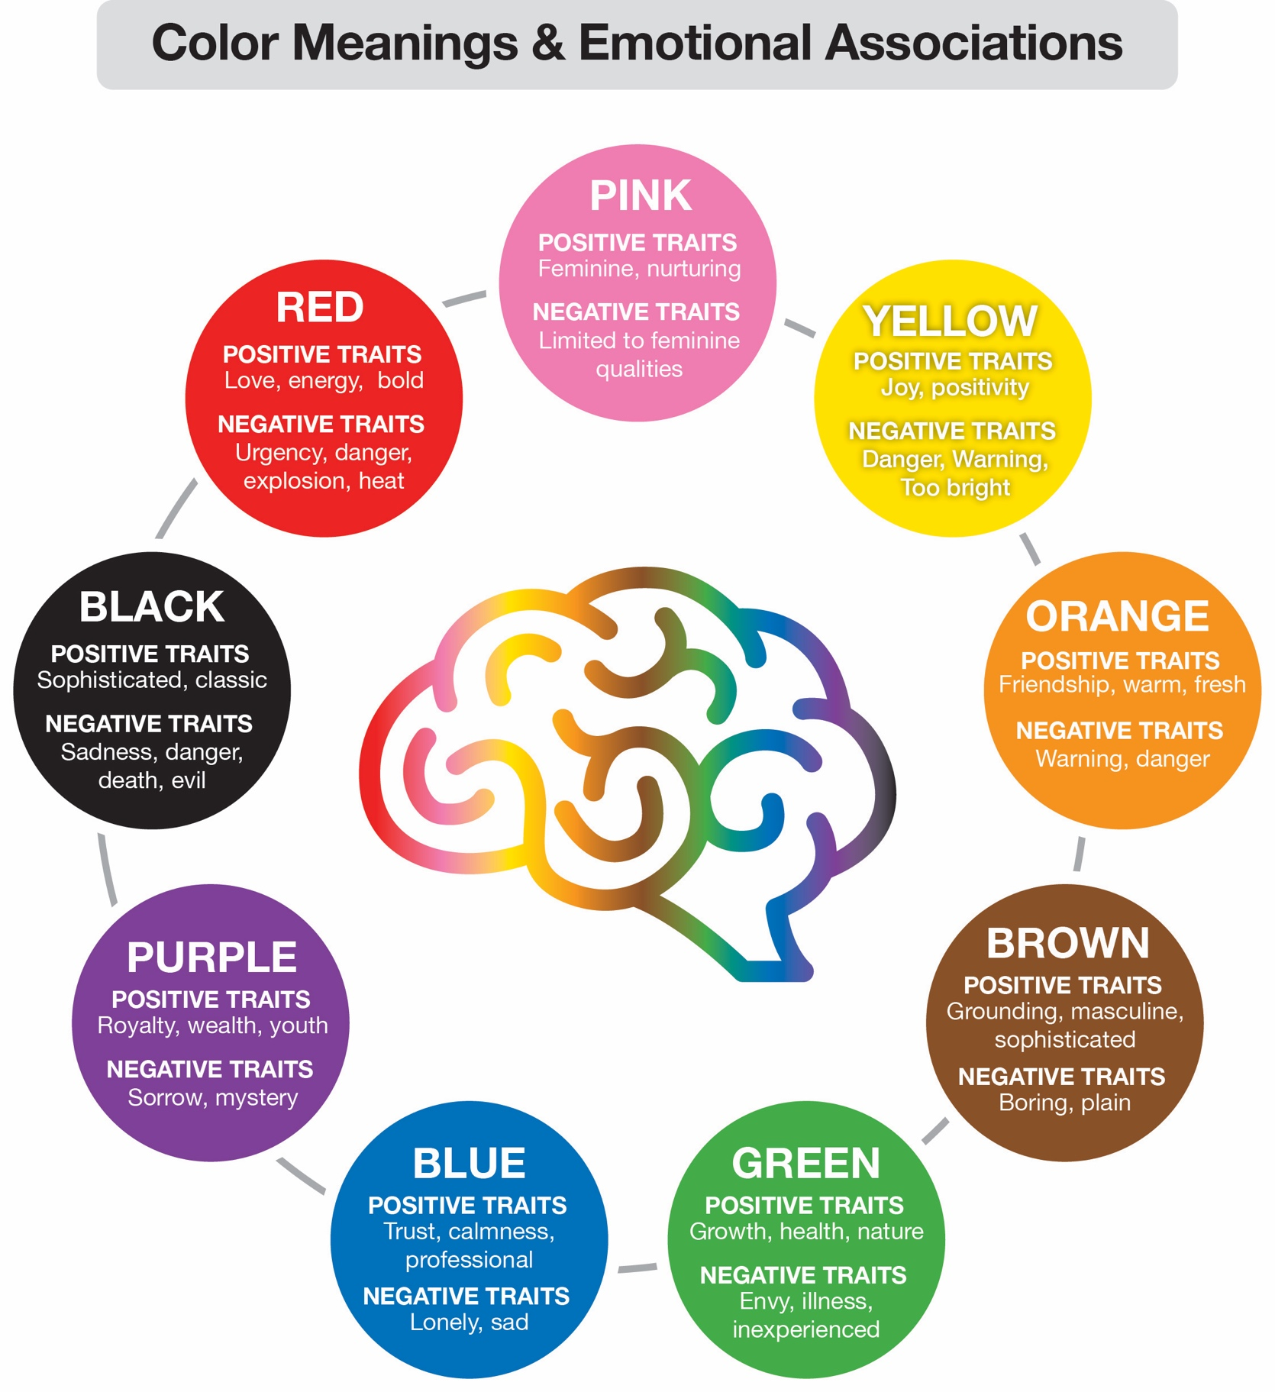
Figure 1: Color Meanings and Emotional Associations. Graphic created by the author based on Sutton (2020), Sun (2023), and The Psychology of Color in Retail Signage.

Figure 2: Color Use in Jewelry Brand Identity
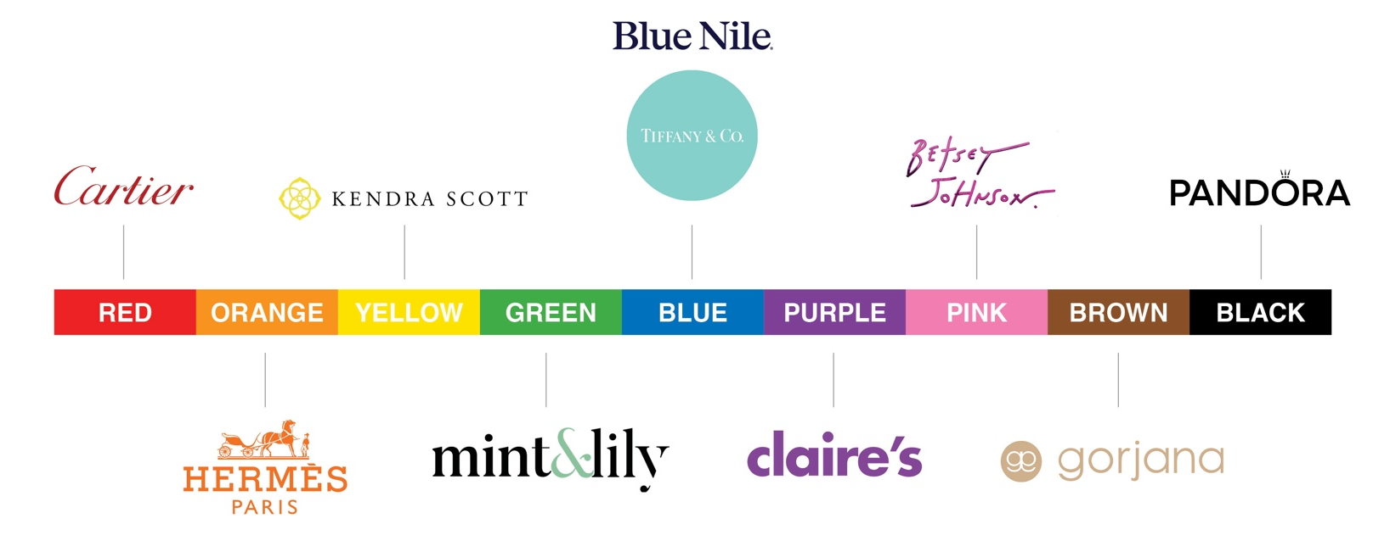

Psychological and Emotional Meanings of Color
A large body of research focuses on the universal emotional and psychological associations of color. Sutton (2020) argues that color functions as a powerful communicative tool that evokes immediate emotional responses and shapes perception. For example, red is commonly associated with power, intensity, and heightened emotion, making it highly effective in attracting attention in advertising. Orange is often linked to friendliness and energy, while yellow conveys brightness, optimism, and movement.
Other colors communicate more stable or subdued meanings. Green, particularly in darker tones, is associated with tradition, wealth, and stability, while blue conveys trust, authority, and dependability. Variations, such as navy blue, further reinforce reliability and professionalism. Purple, especially in lighter tones such as lavender, suggests nostalgia and romanticism, whereas black is associated with sophistication, contrast, and visual dominance. Brown provides a sense of grounding and comfort, while pink conveys softness, romance, and emotional sensitivity (Sutton, 2020).
Importantly, Sutton (2020) emphasizes that color meaning is not fixed but varies with hue, tone, and combinations of hues. For instance, navy blue communicates authority differently than lighter blues, and lavender carries different meanings than deeper purples. This suggests that color operates on a spectrum of meaning, rather than within rigid definitions. Similarly, Lyu (2025) supports these general associations while highlighting that colors can evoke both positive and negative emotional responses depending on context. For example, red may symbolize love and excitement but can also communicate danger or aggression. This duality emphasizes the importance of audience, context, and application in determining how color is interpreted.

Color in Branding and Consumer Perception
In contrast to general color theory, many studies examine how color functions within specific branding and marketing contexts. Zarei (2025) explores the use of pink in gender-targeted marketing, arguing that it operates as both a visual design element and a cultural symbol associated with femininity, empathy, and identity. This makes it a powerful tool in influencing consumer perception and behavior.
Comparably, Sun (2023) investigates the role of green in sustainability branding, demonstrating that color significantly influences brand equity and interacts with perceived brand gender. Additional research highlights how recognizable brand colors—such as red, green, or yellow—contribute to brand recognition and consumer recall (Sun, 2023). Celhay and Luffarelli (2024) further argue that the meaning of color in branding is highly context dependent. While certain colors carry commonly accepted symbolic meanings, these meanings can shift depending on their application. For example, yellow is typically associated with happiness but may signal danger when paired with black in warning-related branding. This demonstrates that composition and context can override generalized color associations.
Color also plays a critical role in packaging design and purchasing behavior. Febrianti et al. (2023) found that packaging color significantly influences first impressions, emotional responses, and consumer decision-making. Their findings suggest that preferences vary across demographic groups, with higher-end consumers tending to prefer darker, cooler tones, while other groups favor brighter, more vibrant palettes. Packaging design, therefore, serves as a key marketing tool at the point of purchase.
In digital environments, the role of color becomes more dynamic and adaptable. Lyu (2025) explains that color functions not only as an aesthetic element but also as a tool for emotional and information communication and for visual hierarchy. The flexibility of digital platforms allows designers to modify color in real time, improving user engagement and experience.

Motion Design and Contemporary Branding
Recent research highlights the growing importance of motion design in branding, particularly in digital contexts. Guan (2025) demonstrates that animated logos can capture and sustain user attention more effectively than static designs. This suggests that motion enhances emotional engagement and visual interest. Ruzin (2022) supports this perspective, emphasizing that effective motion design requires a strong understanding of animation principles, visual consistency, and conceptual development. The increasing accessibility of digital tools has contributed to the widespread use of motion graphics in branding and marketing. Additional studies using eye-tracking and neuromarketing techniques indicate that dynamic logos improve brand recall, emotional engagement, and overall perception (Šola, 2025). These findings reflect a broader shift toward interactive and immersive brand experiences in digital media.
Recent research highlights the growing importance of motion design in branding, particularly in digital contexts. Guan (2025) shows that animated logos capture and sustain user attention more effectively than static designs, suggesting that motion enhances emotional engagement and visual interest. Ruzin (2022) supports this view, emphasizing that effective motion design requires a strong grasp of animation principles, visual consistency, and conceptual development. The growing accessibility of digital tools has fueled the widespread use of motion graphics in branding and marketing. Additional studies using eye-tracking and neuromarketing techniques indicate that dynamic logos improve brand recall, emotional engagement, and overall brand perception (Šola, 2025). These findings reflect a broader shift toward interactive and immersive brand experiences in digital media.
Further evidence of this trend appears in contemporary retail branding practices. Industry reports from Digital Silk (2025) indicate that retailers are increasingly incorporating motion design, animated transitions, and interactive digital experiences to create more engaging customer journeys and strengthen consumer retention. As brands compete for attention in highly saturated digital environments, motion helps guide users, communicate brand personality, and increase perceptions of innovation and modernity. These applications demonstrate how motion can influence consumer engagement while shaping how a brand is perceived.
While motion influences how consumers engage with and remember a brand, color also plays a critical role in shaping consumer perception. Color can communicate emotional qualities, values, and personality traits before any interaction with motion occurs. Consumers often form immediate impressions based on color, associating specific hues with characteristics such as trustworthiness, luxury, creativity, sophistication, or sustainability. As a result, color alone can significantly influence a consumer's initial perception of a brand.
Together, these studies suggest that motion design influences consumer perception by increasing attention, strengthening brand recall, enhancing emotional engagement, and contributing to perceptions of innovation and modernity. Color likewise plays a significant role in shaping perception by communicating a brand's personality, emotional tone, and values. While color can independently influence consumers' first impressions, motion can reinforce and amplify those perceptions through dynamic and memorable experiences. Therefore, integrating both color and motion may create a stronger overall brand experience and a more positive consumer perception than using color alone. The specific effects of the color palette and motion elements utilized in the Quanta & Co. brand identity are discussed later in this paper and documented in the accompanying graphic design process book.
Research Methods in Color and Branding Studies

Many studies in this field rely on surveys, experiments, and analyses of behavioral data to evaluate consumer responses to color. For example, Tian (2023) developed predictive models using consumer interaction data, while Zarei (2025) used qualitative methods to explore gender-based marketing strategies. Similarly, Febrianti et al. (2023) combined surveys and experimental approaches to assess the impact of packaging design on purchasing decisions. While these methods provide valuable insights, they often focus on specific brands or contexts, making it difficult to isolate color as an independent variable.

Methodology
My project, “Color Shift: A Graphic Design Process Book Exploring How Color and Motion Influence Emotional Perception and Brand Connection in Affordable Women’s Fashion Jewelry”, addresses a gap in existing research by isolating color as the primary variable within a controlled branding system. The study investigates the research question: How does manipulating color and motion in a brand identity system influence emotional response and brand consistency?
Unlike prior studies that analyze multiple brands or variables simultaneously, this project applies multiple color palettes to a single, consistent brand identity, Quanta & Co. By maintaining consistent logo design, typography, and layout, the study enables a more precise examination of how color alone influences perception.
Additionally, this project introduces a unique methodological and creative approach through its format as a visual research and interactive process book. It documents the full design process, including logo development, wireframes, and color applications, offering a more immersive and practice-based contribution to the field.
Furthermore, this study expands existing research by incorporating animated logo variations, an area that remains underexplored in color-focused branding studies. As motion design becomes increasingly central to digital branding, analyzing how animation interacts with color provides new insight into contemporary design practices.
Finally, the study used a quantitative survey methodology in which participants evaluated different color variations of the same brand and described their emotional responses. This approach aligns with existing research methods while offering a more controlled investigation of color as an independent variable.
Participants
Participants were recruited to complete an online survey evaluating variations of a single brand identity for Quanta & Co., a fictional modern jewelry brand positioned within the contemporary mid-range jewelry market. The brand was developed to appeal to consumers seeking stylish, modern jewelry at an accessible price point. Its positioning reflects brands commonly found in retail environments such as Target, offering fashionable and elevated pieces that feel more refined than budget jewelry options while remaining more approachable than luxury or specialty jewelry retailers.
Participants included adults who currently purchase or have previously purchased jewelry for themselves or as gifts, as these individuals represent the brand's intended consumer audience. The survey asked participants to evaluate visual variations of the Quanta & Co. brand identity across a range of branded touchpoints, including print materials, such as a business card; packaging elements, such as a jewelry box and shopping bag; large-scale applications, such as a vehicle wrap; digital assets, including a web advertisement and website homepage, and a motion design component in the form of an animated logo.
The primary objective of the survey was to examine how color influenced perceptions of value, style, and brand personality. To isolate the effects of color within the motion design component, the animated logo was intentionally limited to logo animation only. No sound effects, jewelry products, human models, or additional visual elements were included, ensuring that color remained the primary variable influencing participant responses. Participation was voluntary, and all responses remained anonymous in accordance with Institutional Review Board (IRB) guidelines.
Materials
The primary materials for this study include a series of static and motion graphics featuring the Quanta & Co. brand identity presented in nine distinct color variations: red, orange, yellow, green, blue, purple, pink, black, and brown. Each variation maintains consistent logo design, typography, and layout to isolate color as the primary variable. Both static and animated logo versions are included to evaluate the interaction between color and motion design.
The survey, created using Qualtrics, consists of nine standardized questions for each color condition. These questions include both open-ended responses and closed-ended items designed to assess initial impressions, emotional responses, perceived brand traits, brand fit, perceived quality (from low-end to high-end), and the impact of animation on brand perception.
Procedure
The survey was created using Qualtrics and was distributed electronically to participants. To minimize survey fatigue and enhance response quality, each participant was randomly given four out of the nine color options to assess.
For each assigned color variation, participants responded to a consistent set of nine questions. These questions prompt participants to describe their first impressions, identify emotional associations, select applicable brand traits, and evaluate how well the color aligns with the brand identity. Additional items assessed perceived brand value and the influence of animation on appeal and clarity. The survey concluded with an open-ended question allowing participants to provide additional feedback.
The survey was open for approximately 10 days. Upon closure, responses were collected and prepared for analysis.
Data Analysis
Data from the survey was collected completion using Cayuse. Responses were reviewed to identify recurring themes related to emotional perception and brand association across color variations. Scaled and multiple-choice questions were analyzed to compare patterns in participant responses across different colors and animation conditions.
This approach helped understand both thematic ideas and structured comparisons, making it easier to see how color and motion influence how people perceive a brand. The insights gained directly helped in creating the final graphic design process book. The recurring themes identified through this analysis are summarized in the infographic below, highlighting how each color influenced emotional perception, perceived quality, and overall brand alignment for Quanta & Co. Figure 3 visually summarizes these key findings and their relationship to the Quanta & Co. brand identity.

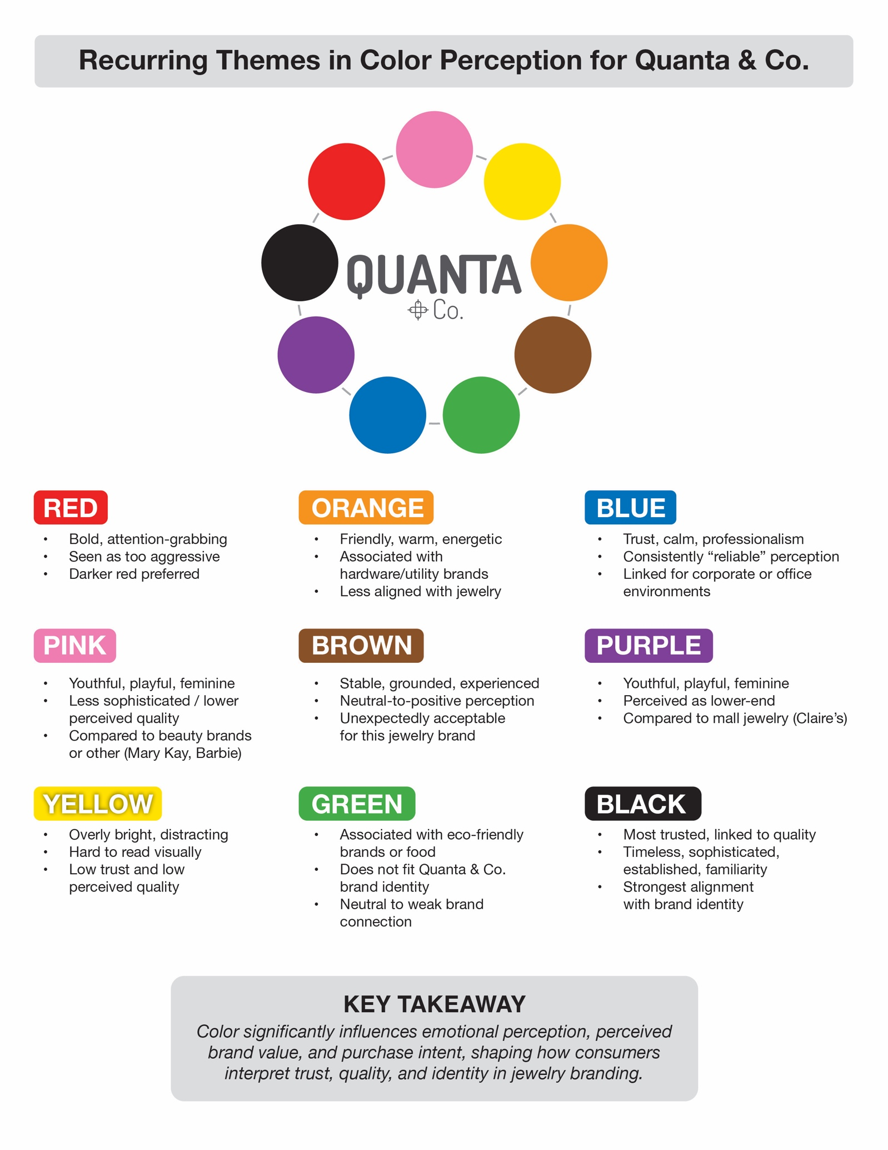
Figure 3: Color Perceptions and Brand Alignment for Quanta & Co. Infographic created by the author summarizing key findings from the research and design process.
Timeline
The anticipated timeline for completing my prospectus begins with the fact that I have already developed most of the final layout for my graphic design process book. I have analyzed the collected data, which has allowed me to prepare and refine my findings for the remainder of the current term.
Afterward, I will finalize the process book by completing the remaining layout design, incorporating survey insights, and integrating any additional research gathered from relevant sources. The final stage will involve completing all written components to ensure a cohesive and comprehensive presentation of the project. I have maintained regular communication with my committee, seeking feedback and guidance as needed, and their support has been invaluable throughout this process. I will continue to stay connected with them as I move toward completing the project.
Production and Discussion of Results
The primary findings of this project demonstrated that color significantly influences emotional perception, perceived brand value, and trust in fashion jewelry branding. Survey responses revealed that participants consistently associated specific colors with distinct emotional and brand-related expectations. Darker, more neutral tones, particularly black, generated the strongest perceptions of trust, brand fit, and quality. Blue also performed positively, reinforcing credibility and professionalism while aligning with a polished, reliable brand image.
In contrast, brighter, more saturated colors, such as yellow, pink, and purple, were more frequently associated with youthfulness, playfulness, or lower-end jewelry branding. These responses showed that color directly shapes how consumers interpret product quality and whether a brand aligns with their expectations of jewelry branding. Motion-based animation also influenced perception by increasing engagement and drawing attention to color, while in some cases reinforcing emotional associations already established through static visuals.
These findings support the project’s central insight that color serves as a strategic branding tool that shapes emotional trust, perceived value, and purchase intent. The survey results confirmed that color serves not just as an aesthetic choice but also as a communication tool that influences how consumers understand and emotionally engage with a brand.
The final graphic design process book serves as both a research documentation tool and a visual translation of the survey findings. Layouts, infographics, and branded applications were designed to communicate the data clearly while demonstrating how audience feedback directly shaped the development of Quanta & Co. This approach strengthened the connection between research and visual execution throughout the project.

Evaluation, Analysis, and Interpretation of the Final Project
The final project successfully translated research findings into a cohesive visual branding case study for Quanta & Co. The combination of survey analysis, color exploration, and motion-based design created a direct relationship between research and creative execution. Participant responses confirmed that color selection can influence trust, perceived quality, and emotional connection before a consumer engages with the product itself.
The most prominent example was black, which participants consistently linked to timelessness, positive brand alignment, and expected quality, aligning closely with Quanta & Co.’s intended brand image. Blue also conveyed trust and professionalism. In contrast, brighter colors like yellow, pink, and purple were seen as more playful or youthful, which often diminished perceptions of Quanta & Co.'s modernity and accessibility. These results highlight how color impacts audience expectations and can affect a jewelry brand's marketplace positioning.
This project contributes to the field of graphic design by reinforcing the value of research-informed branding decisions. While color psychology is often discussed conceptually within branding, this project applied those theories in a focused fashion jewelry context and paired them with direct audience feedback to better understand emotional perception. A unique contribution of this project was the incorporation of real-time participant responses and written feedback throughout the survey process, allowing for honest and immediate insight into how individuals perceived the Quanta & Co. brand across the four color variations they were assigned. These responses—whether positive, negative, or neutral—provided valuable context beyond numerical data and helped reveal deeper emotional and brand-related associations. The final work demonstrates how graphic designers can use intentional color strategy alongside audience-centered research to create stronger brand alignment and more effective visual communication.
Conclusion
This project successfully met its primary objectives by exploring how color influences emotional perception, perceived brand value, and identity within a fashion jewelry context. Through the development of the Quanta & Co. branding system, survey-based research, and design exploration, the project demonstrated that color is a critical factor in shaping how consumers interpret trust, quality, and accessibility in a brand. The final outcome—a comprehensive graphic design process book supported by visual and motion-based applications—effectively translated research findings into a cohesive brand identity system.
In terms of contribution to the discipline, this project reinforces the importance of research-informed design within branding practice. Although color psychology is commonly discussed in design theory, this study offers a practical, data-based outlook by integrating audience feedback with visual experiments specifically in the context of fashion jewelry. The originality of the project lies in its integration of real-time participant responses, which provided direct insight into emotional and perceptual reactions, rather than relying solely on theoretical assumptions.
The strengths of this project include its survey-based research approach and design process book, which presents clear written summaries and key insights for each color variation. The project also offers a unique perspective through the development of a custom-designed brand identity, including a logo created from scratch, supporting brand mood boards, motion wireframes, and a prototype website. Additionally, participant feedback was directly integrated into the design process through each color variation, allowing for meaningful comparison between initial design intent and audience perception. The scope of the project demonstrates a comprehensive application of graphic design principles, combining both visual development and supporting research across the process book and project paper.
The integration of motion design alongside static branding elements further strengthened the exploration of how animation influences engagement and emotional perception. However, several limitations should be acknowledged. Responses were based on Quanta & Co., a hypothetical brand, allowing participants to evaluate the visual identity without preconceived opinions associated with an existing company. While this created a more neutral testing environment, participants' perceptions may have differed in a real-world purchasing experience that included physical brand interactions, such as shopping bags and jewelry packaging, as well as an in-store retail environment. Another limitation was that each participant was exposed to only four of the nine color variations to reduce survey fatigue. While this improved completion rates, it also meant that not all participants evaluated the full color range, which may have affected the consistency of comparisons across responses. Finally, the study primarily focused on color as the central variable and did not deeply isolate or test other branding components, such as typography, texture, or pricing strategy, which could also significantly impact brand perception.
This research builds on existing studies in color psychology and branding by applying them specifically within the context of accessible fashion jewelry branding. It supports existing literature suggesting that color influences emotional response, while also demonstrating how these effects vary depending on brand positioning and audience expectations. The findings suggest that familiar color associations (such as black for luxury or blue for trust) remain highly influential in consumer perception.
Future iterations of this project could expand the participant pool to include a more diverse demographic, as well as test additional branding elements such as typography, packaging materials, and in-store experience design. Further exploration of motion-based branding could also provide deeper insight into how animation affects emotional engagement and brand recall across digital platforms.
Overall, this thesis demonstrates that color is not merely a visual choice, but a strategic branding tool that directly shapes emotional perception, brand trust, and perceived value. The Quanta & Co. project highlights how intentional, research-informed design decisions can create stronger and more meaningful connections between a brand and its audience.

References
California retail brands embrace motion design & mobile UX in 2025 web overhauls, says
Digital Silk. (2025, April 21). PR Newswire. https://go.gale.com/ps/i.do?p=ITBC&u=sain20269&id=GALE%7CA836416504&v=2.1&it=r&sid=ebsco
Celhay, F., & Luffarelli, J. (2024). Competent or sad blue? Lively or aggressive red? Why, how,
and when background color shapes the meanings of logo hues. Journal of Consumer
Research, 51(4), 820–844. https://doi.org/10.1093/jcr/ucae019
Febrianti, I. A., Widodo, A. S., & Faizin, A. (2023). The effectiveness of canned coffee
packaging’s graphic design elements in consumers’ decision-making process. Journal of Graphic Engineering & Design, 14(4), 5–12. https://doi.org/10.24867/JGED-2023-4-005
Guan, W., Cho, D. M., & Zheng, L. (2025). Embracing chaos: The unpredictability of animated
logos shapes users’ sustained attention. Frontiers in Psychology, 1–19.
https://doi.org/10.3389/fpsyg.2025.1642722
Lyu, H. (2025). A study of the role of color in visual communication in the digital
perspective. Mediterranean Archaeology & Archaeometry, 25(1), 352–357.
Ruzin, M. (2022). The craft of motion design in the 2020s. Vizione, 39, 121–128.
Šola, H. M., Khawaja, S., & Qureshi, F. H. (2025). Neuroscientific analysis of logo design:
Implications for luxury brand marketing. Behavioral Sciences (2076-328X), 15(4), 502.
https://doi.org/10.3390/bs15040502
Sun, M., & Kim, J. (2023). Sustainability and brand equity: The moderating role of brand color
and brand gender. Sustainability, 15(11). https://doi.org/10.3390/su15118908
Sutton, T. (2020). The pocket complete color harmony: 1,500+ color palettes for designers,
artists, architects, makers, and educators. Rockport Publishers.
Tian, H. (2023). The application of advertising logo color design for big data and visual
communication technology. Journal of Computational Methods in Sciences &
Engineering, 23(3), 1479–1490. https://doi.org/10.3233/JCM-226700
Zarei, G., & Arbatan, G. A. (2025). Women-centric marketing: A model for pink branding in
sports equipment. Sports Marketing Studies, 6(1), 15–31.
https://doi.org/10.22034/sms.2025.142907.1460

